INSERT INTO furnizor VALUES(1, 'Nike Delivery');

INSERT INTO furnizor VALUES(2, 'Adidas Delivery');

INSERT INTO furnizor VALUES(3, 'Vans Delivery');

INSERT INTO furnizor VALUES(4, 'Off-White Delivery');

INSERT INTO furnizor VALUES(5, 'Jordan Delivery');

SELECT \* FROM furnizor;

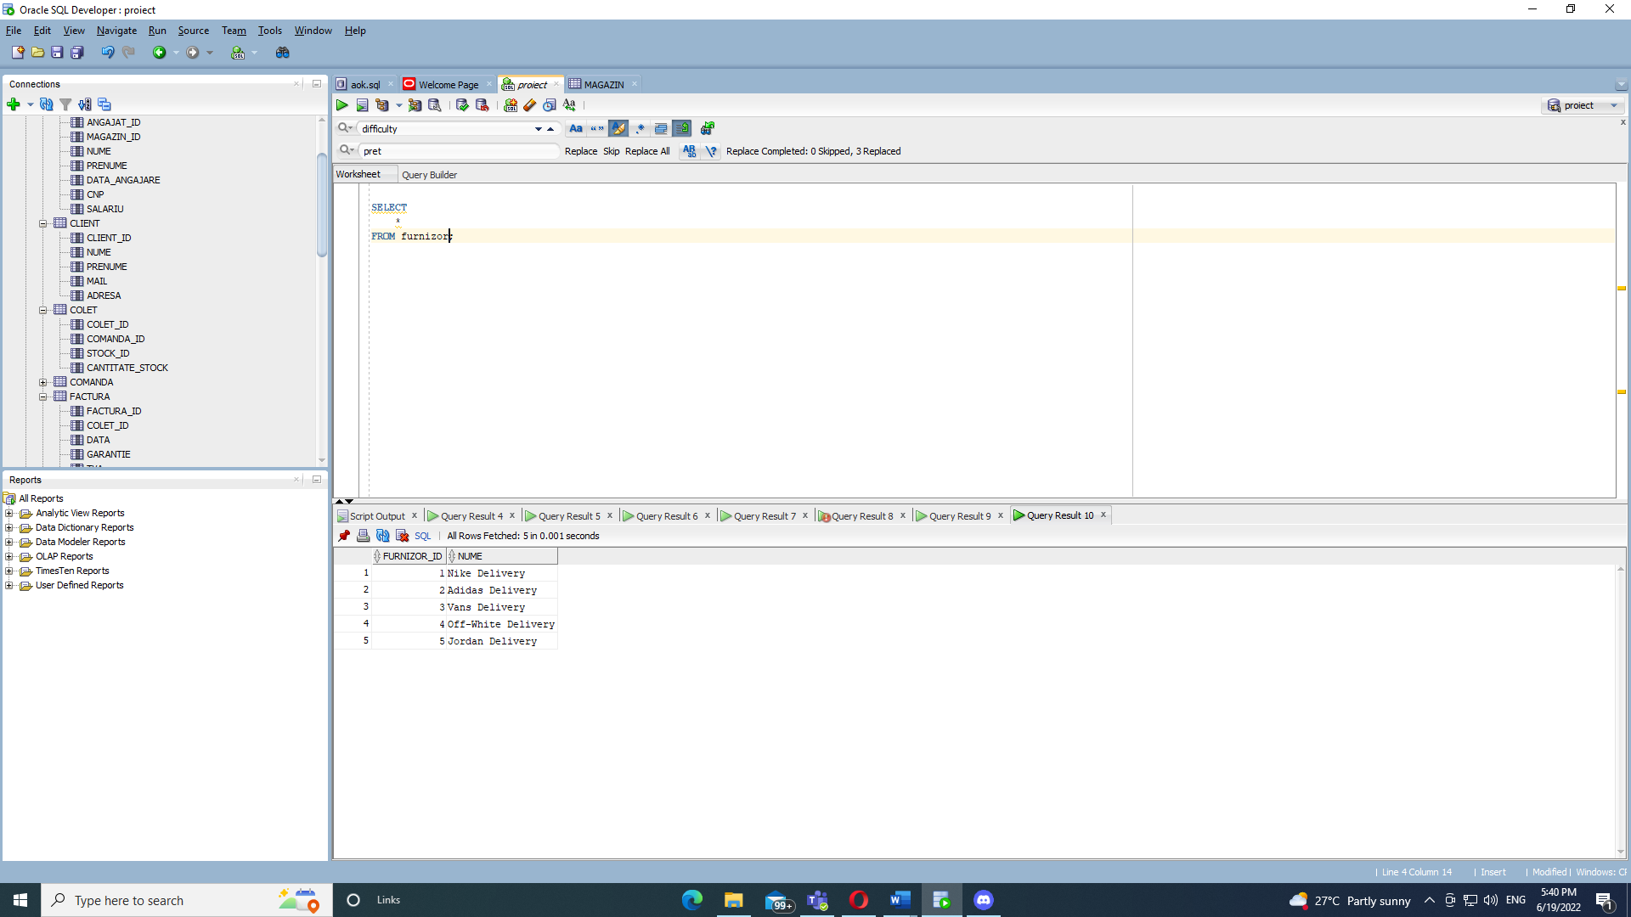

INSERT INTO magazin VALUES(1, 'Bucuresti', 'Bulevardul Ion C. Bratianu nr 44');

INSERT INTO magazin VALUES(2, 'Bucuresti', 'Bulevardul Libertatii 9' );

INSERT INTO magazin VALUES(3, 'Bucuresti', 'BD. MIHALACHE ION nr. 1');

INSERT INTO magazin VALUES(4, 'Cluj', 'PIATA MANIU IULIU nr. 20');

INSERT INTO magazin VALUES(5, 'Constanta', 'Piata Marasti 3');

SELECT \* FROM magazin;

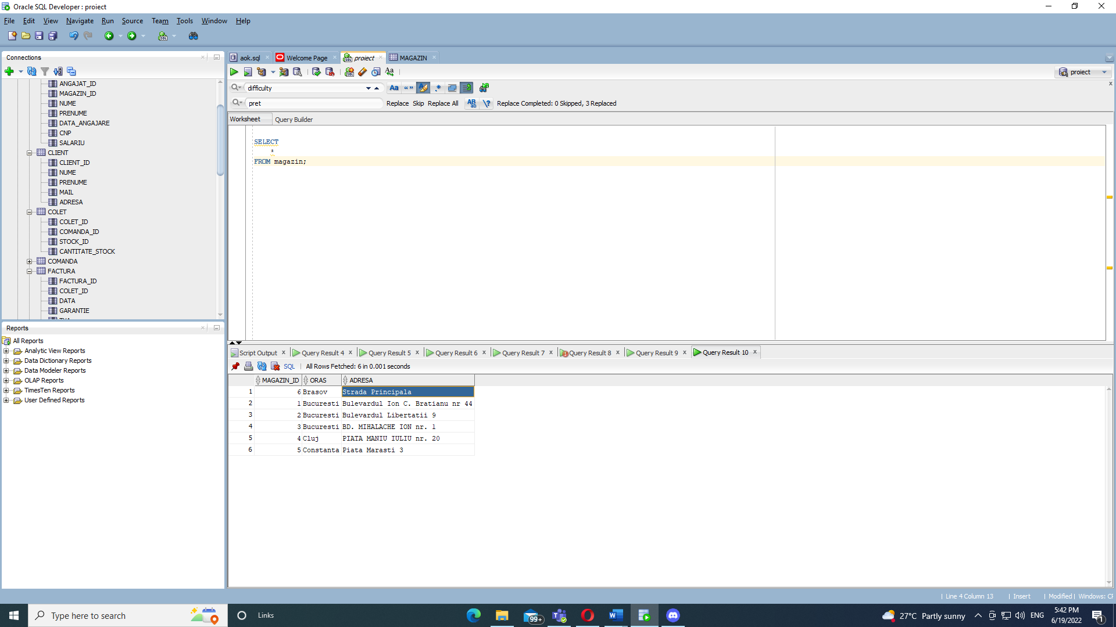

INSERT INTO angajat VALUES(1, 1, 'Ionescu', 'Stefan', '02-JAN-2013', '2952632094297', 2500);

INSERT INTO angajat VALUES(2, 2, 'Gheorghiu', 'Alex', '23-MAR-2010', '5509775868159', 3500);

INSERT INTO angajat VALUES(3, 1, 'Popa', 'Ionut', '12-JUL-2019', '7019075909822', 2000);

INSERT INTO angajat VALUES(4, 2, 'Murica', 'Andrei', '07-DEC-2015', '8258835403679', 5000);

INSERT INTO angajat VALUES(5, 1, 'Ciobanu', 'Stefan', '23-JAN-2016', '0684400627098', 2500);

SELECT \* FROM angajat;

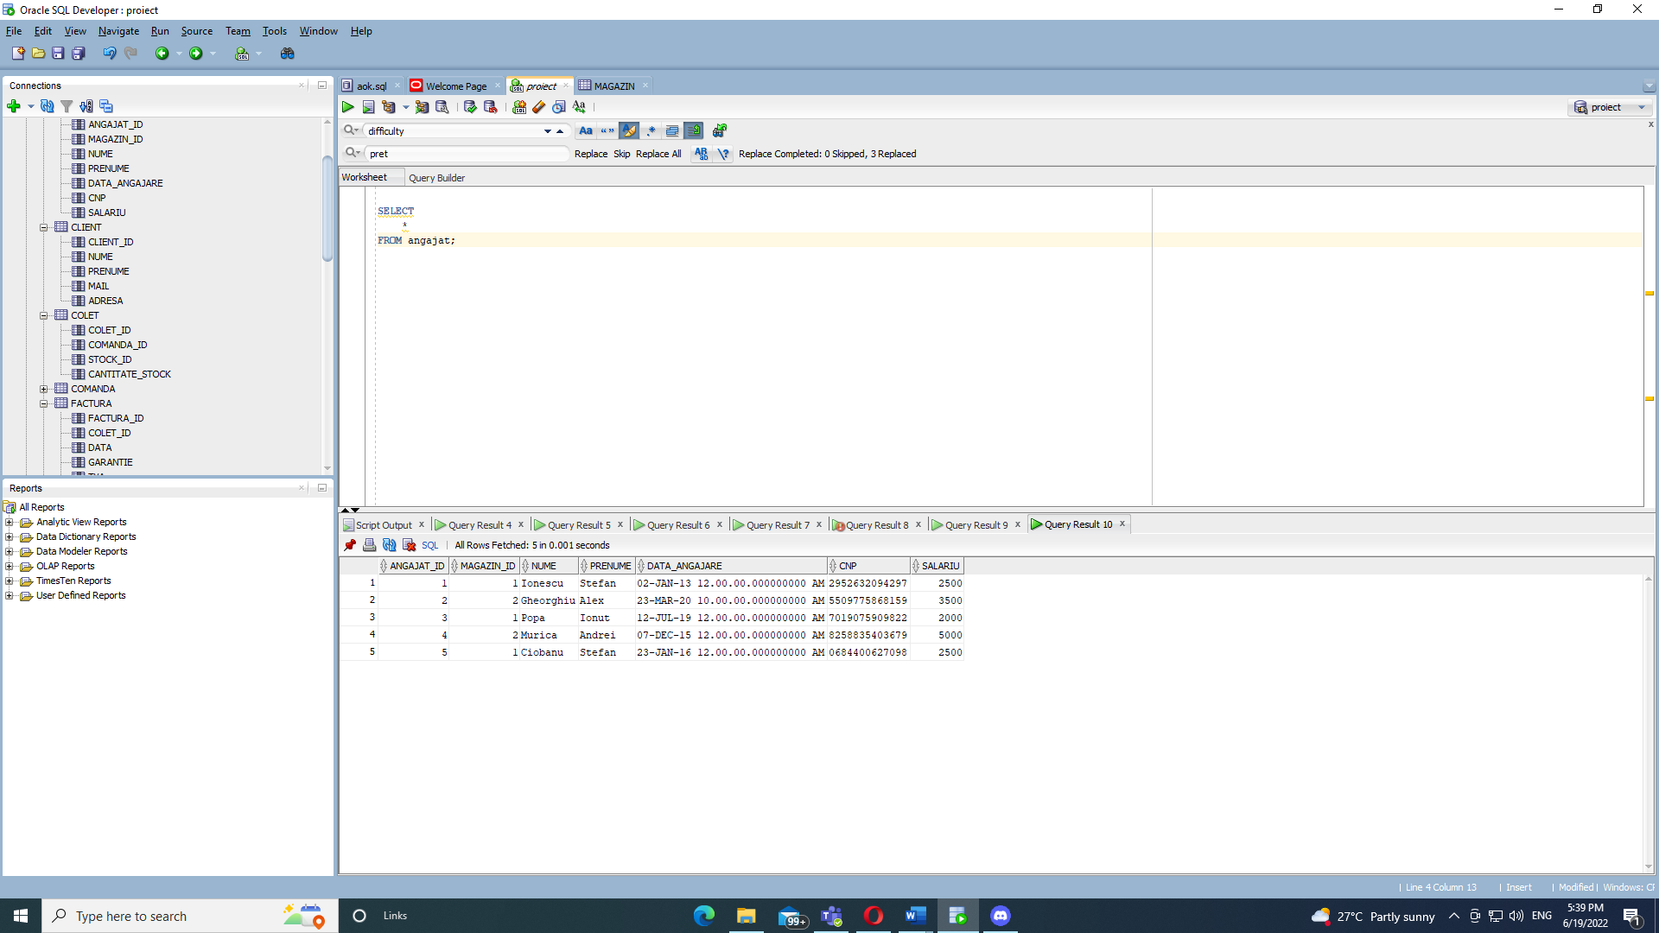

INSERT INTO client VALUES(1, 'Popescu', 'Stefan', 'popstef@gmail.com', 'Str Stefan cel mare 12');

INSERT INTO client VALUES(2, 'Stanciu', 'Mihai', 'mishu@gmail.com', 'Str Valea Argesului 18');

INSERT INTO client VALUES(3, 'Grigore', 'Dragos', 'dragosg@yahoo.com', 'Str Obor 3');

INSERT INTO client VALUES(4, 'Roman', 'Andrei', 'andyroman@yahoo.com', 'Str Piata Victoriei 20');

INSERT INTO client VALUES(5, 'Stan', 'Andrei', 'andreistan@gmail.com', 'Str Dezrobirii 17');

INSERT INTO client VALUES(6, 'Murica', 'Andrei', 'andreimurica@gmail.com', 'Str Vintila Mihailescu nr 14');

SELECT \* FROM client;

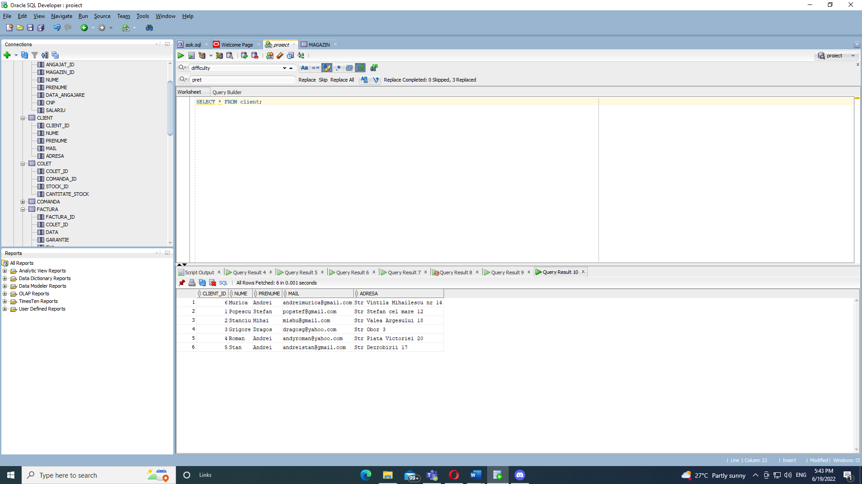

INSERT INTO comanda VALUES(1, 1, 1, 'Plasata', 850);

INSERT INTO comanda VALUES(2, 1, 1, 'Finalizata', 500);

INSERT INTO comanda VALUES(3, 2, 1, 'Pe drum', 1000);

INSERT INTO comanda VALUES(4, 1, 2, 'Pregatita', 650);

INSERT INTO comanda VALUES(5, 3, 2, 'Pregatita', 700);

INSERT INTO comanda VALUES(6, 4, 4, 'Pregatita', 850);

INSERT INTO comanda VALUES(7, 4, 3, 'Pe drum', 650);

INSERT INTO comanda VALUES(8, 1, 5, 'Finalizata', 450);

INSERT INTO comanda VALUES(9, 1, 5, 'Plasata', 1500);

INSERT INTO comanda VALUES(10, 5, 1, 'Plasata', 900);

SELECT \* FROM comanda;

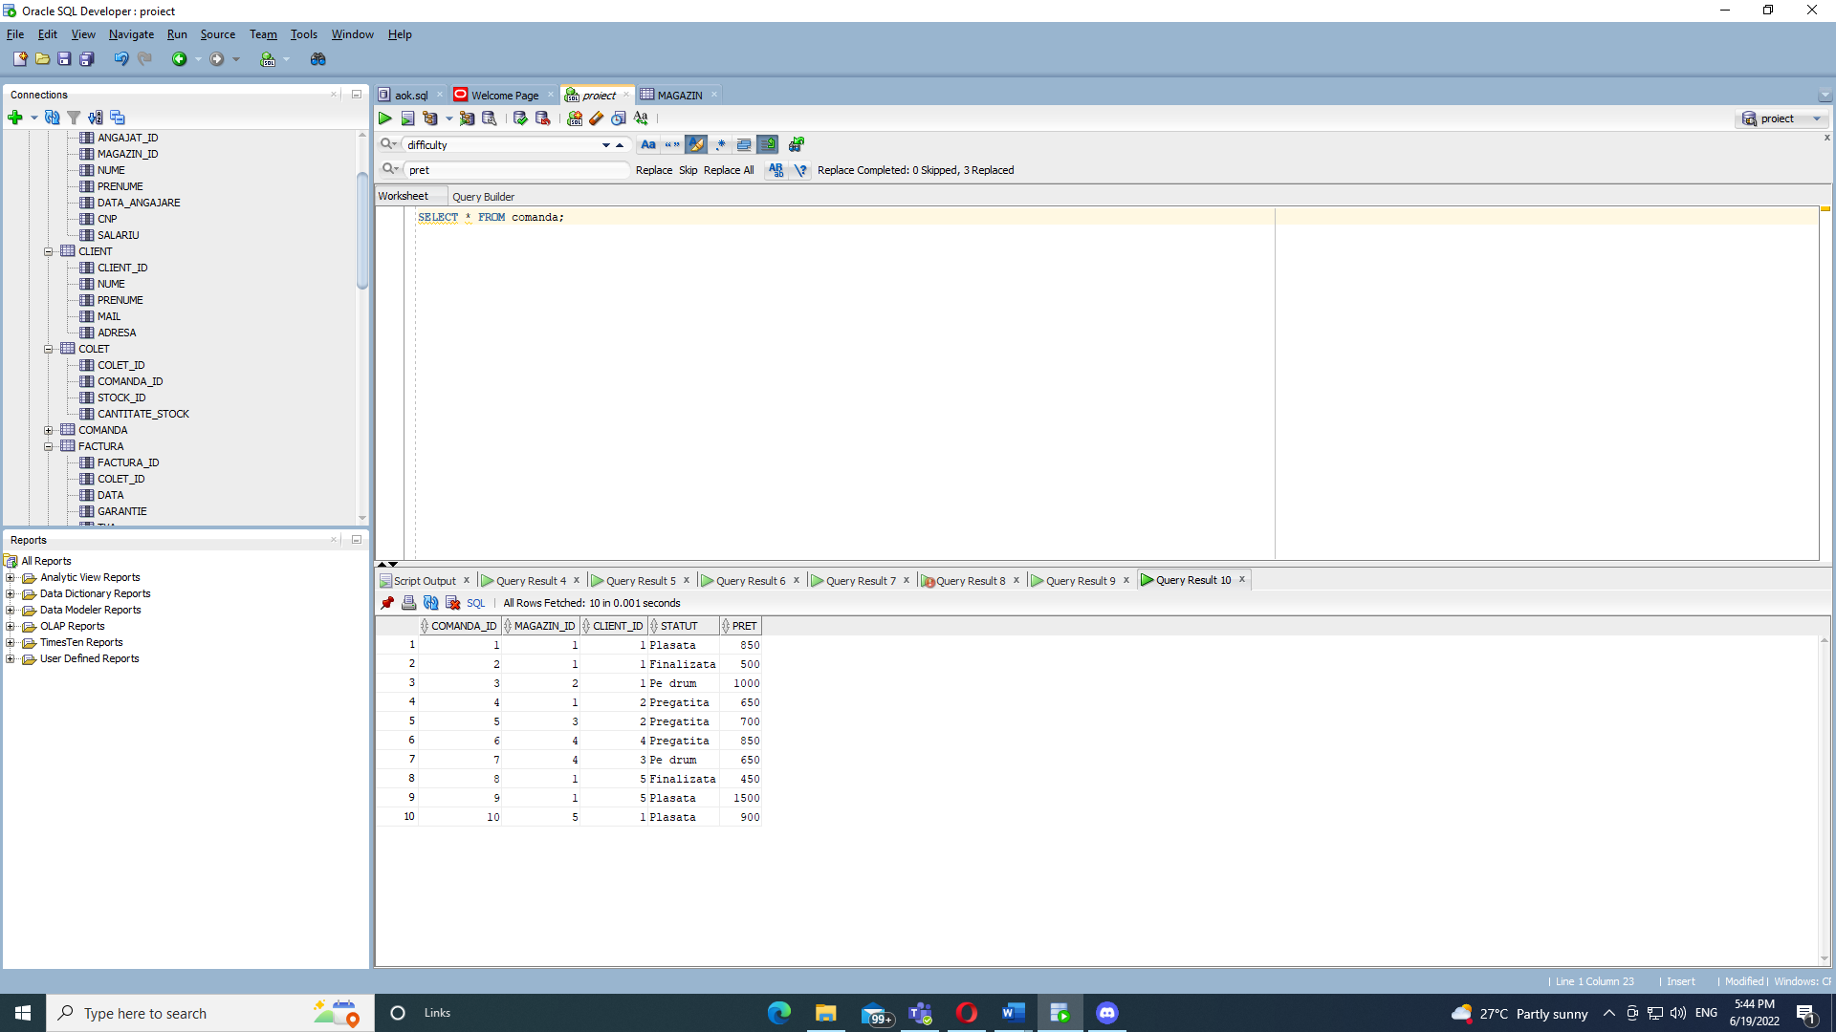

INSERT INTO produs VALUES(1, 'Nike black', 'negru', 'Cei mai buni adidasi negri');

INSERT INTO produs VALUES(2, 'Jordan 1', 'rosu', 'Nu sunt ieftini dar merita din plin' );

INSERT INTO produs VALUES(3, 'Adidas white', 'alb', 'Albul se murdareste repede dar se curata usor');

INSERT INTO produs VALUES(4, 'Jordan 6', 'negru', 'Model nou de vara dar merg si-n iarna');

INSERT INTO produs VALUES(5, 'Nike retro', 'alb', 'Un model mai vechi de dragul vremurilor bune');

SELECT \* FROM produs;

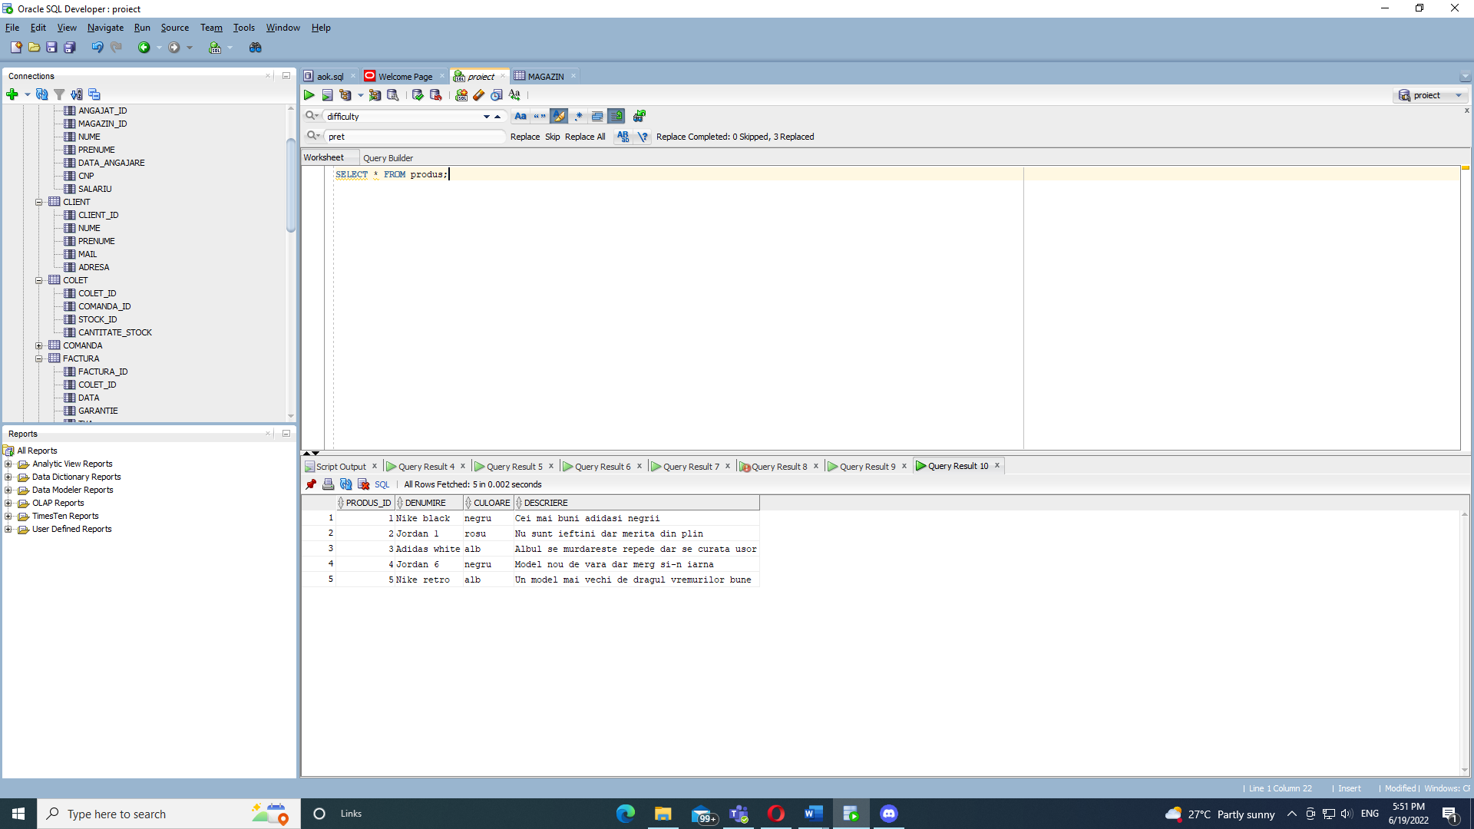

INSERT INTO marfa VALUES(1, 1, 1, 1, 10, '12-MAY-2020', 41, 650);

INSERT INTO marfa VALUES(2, 1, 1, 1, 15, '15-MAY-2020', 42, 650);

INSERT INTO marfa VALUES(3, 2, 1, 2, 8, '12-JUL-2020', 41, 500);

INSERT INTO marfa VALUES(4, 1, 2, 2, 18, '02-MAY-2020', 40, 450);

INSERT INTO marfa VALUES(5, 3, 2, 2, 22, '25-JUL-2020', 43, 550);

INSERT INTO marfa VALUES(6, 4, 4, 3, 10, '12-MAY-2020', 44, 850);

INSERT INTO marfa VALUES(7, 4, 3, 4, 15, '12-MAY-2020', 39, 350);

INSERT INTO marfa VALUES(8, 1, 5, 5, 20, '12-MAY-2020', 40, 600);

INSERT INTO marfa VALUES(9, 1, 5, 5, 20, '12-MAY-2020', 43, 350);

INSERT INTO marfa VALUES(10, 5, 1, 3, 15, '12-MAY-2020', 37, 450);

SELECT \* FROM marfa;

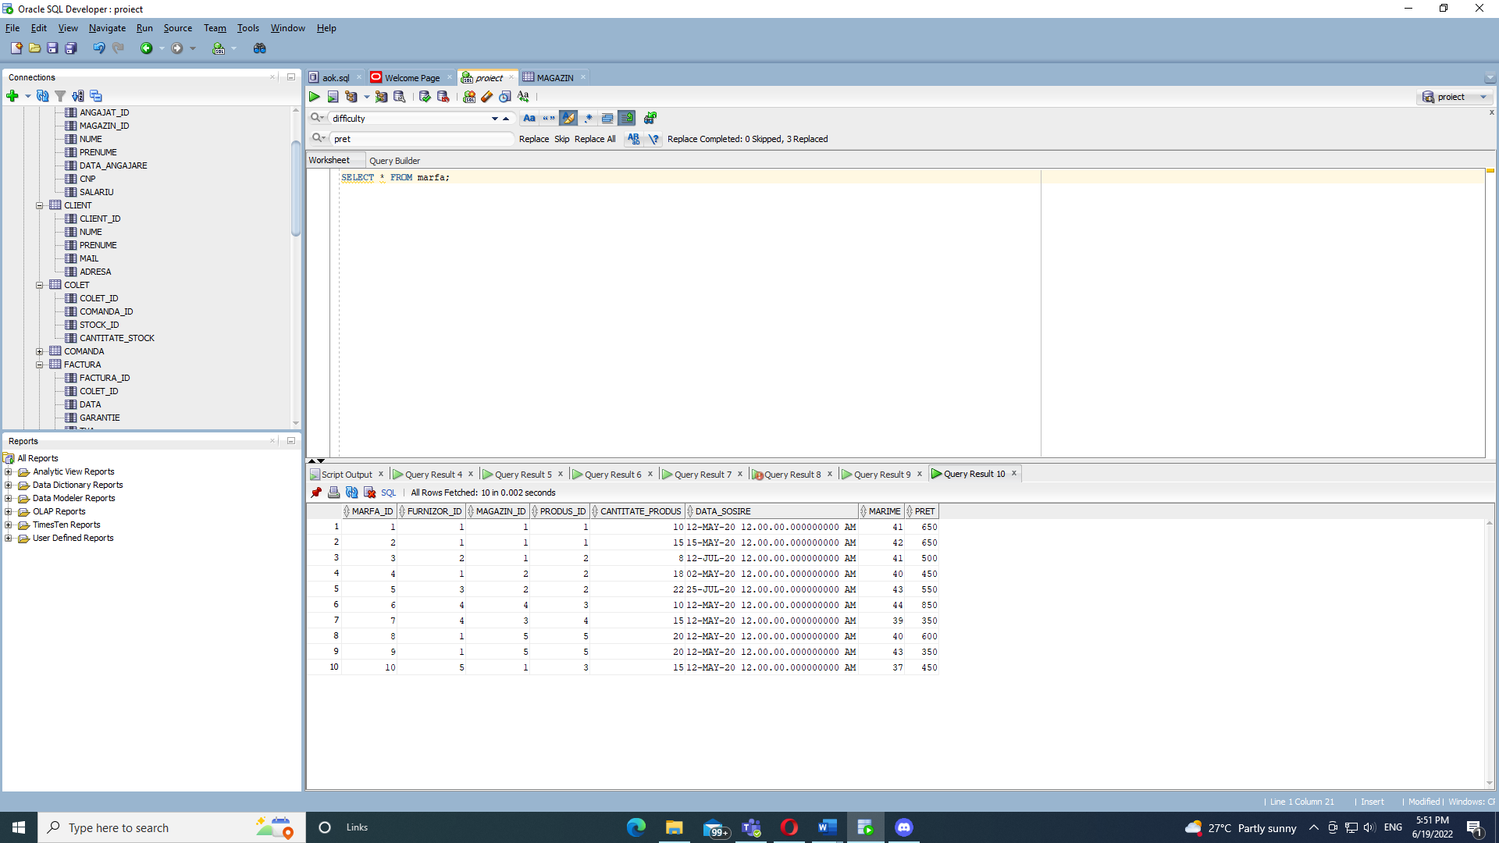

INSERT INTO stock VALUES(1, 1, 1, 10, 41, 750);

INSERT INTO stock VALUES(2, 1, 1, 15, 42, 750);

INSERT INTO stock VALUES(3, 1, 2, 8, 41, 600);

INSERT INTO stock VALUES(4, 2, 2, 18, 40, 550);

INSERT INTO stock VALUES(5, 2, 2, 22, 43, 650);

INSERT INTO stock VALUES(6, 4, 3, 10, 44, 1000);

INSERT INTO stock VALUES(7, 3, 4, 15, 39, 450);

INSERT INTO stock VALUES(8, 5, 5, 20, 40, 700);

INSERT INTO stock VALUES(9, 5, 5, 20, 43, 450);

INSERT INTO stock VALUES(10, 1, 3, 15, 37, 550);

SELECT \* FROM stock;

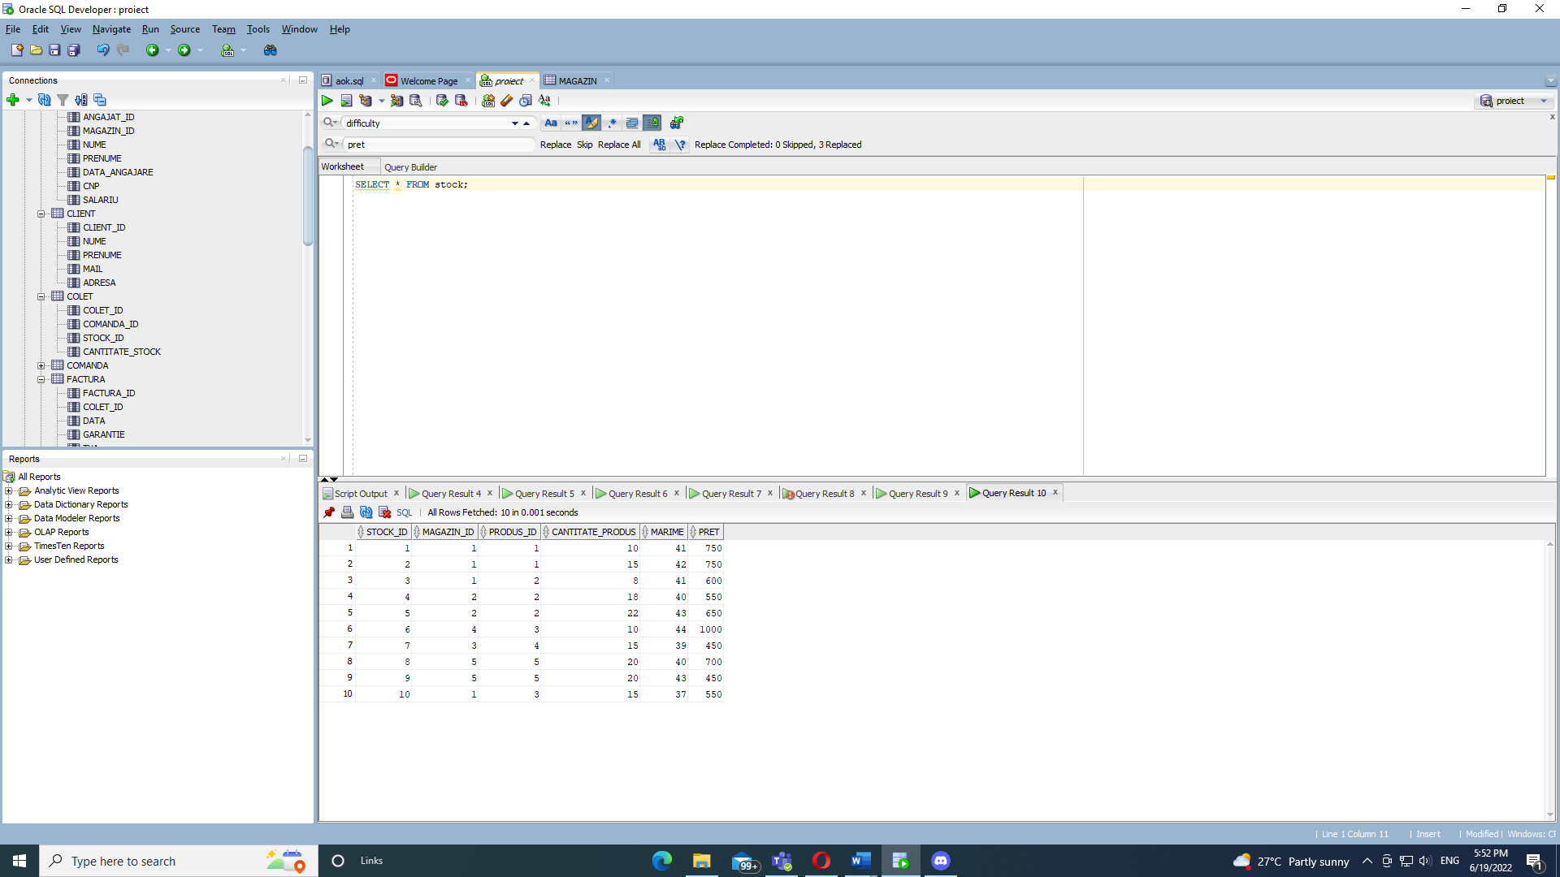

INSERT INTO colet VALUES(1, 1, 1, 1);

INSERT INTO colet VALUES(2, 1, 2, 2);

INSERT INTO colet VALUES(3, 2, 3, 1);

INSERT INTO colet VALUES(4, 6, 4, 3);

INSERT INTO colet VALUES(5, 7, 7, 1);

INSERT INTO colet VALUES(6, 4, 3, 2);

INSERT INTO colet VALUES(7, 3, 6, 1);

INSERT INTO colet VALUES(8, 5, 5, 2);

INSERT INTO colet VALUES(9, 5, 8, 2);

INSERT INTO colet VALUES(10, 1, 3, 1);

SELECT \* FROM colet;

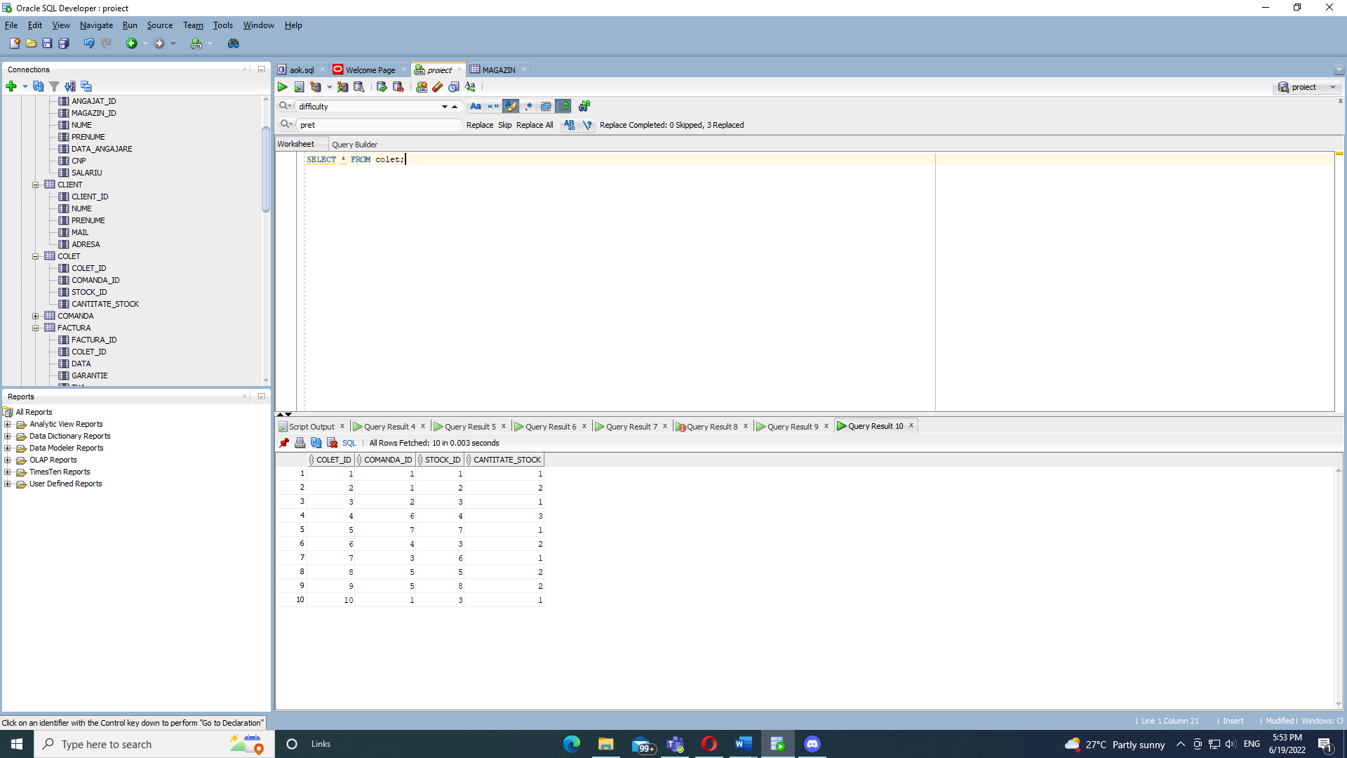

INSERT INTO factura VALUES(1, 1, '12-MAY-19', '12-MAY-21', 100);

INSERT INTO factura VALUES(2, 9, '12-MAY-21', '12-JUL-20', 70);

INSERT INTO factura VALUES(3, 2, '16-DEC-20', '16-MAY-22', 61);

INSERT INTO factura VALUES(4, 5, '30-SEP-10', '22-MAY-22', 150);

INSERT INTO factura VALUES(5, 3, '30-MAY-20', '30-MAY-22', 60);

SELECT \* FROM factura;

